COMPASSION WORKSHOP
This 30 minute workshop will give family members and caregiving staff the ability to connect on a compassionate level with their senior loved ones or clients.
Compassion is at the very essence of caring for another person. Without true compassion, we don’t really see beyond the physical limitations to see the person’s feelings, perspective and suffering. Understanding someone else’s suffering and being motivated to relieve that suffering is the actual definition of compassion.
HOW DO YOU TEACH COMPASSION??
The speaker, Jane Butler, has operated Accessible Home Health Care for over 10 years, an International Franchise with the slogan “We Guarantee Compassionate Care”. She has been giving this workshop to every one of her new hires since the early days of her business inception. The exercise takes the participants through a vivid and interactive simulation of restrictions and losses the elderly face. The exercise is so powerful that even many of the experienced caregivers have claimed they felt more connected to the experience of what an elderly person must face on a daily basis.

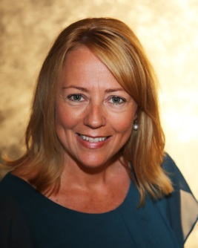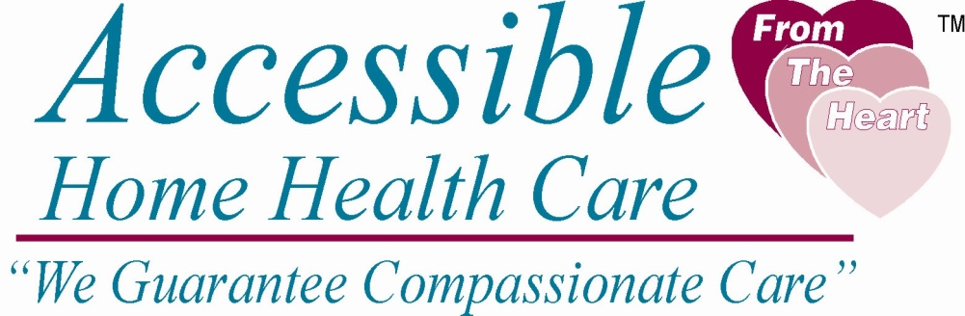
Contact Jane Butler at jbutler@ahcglobal.com or call 610-668-1802 to book your Compassion Workshop. The workshop is FREE!

